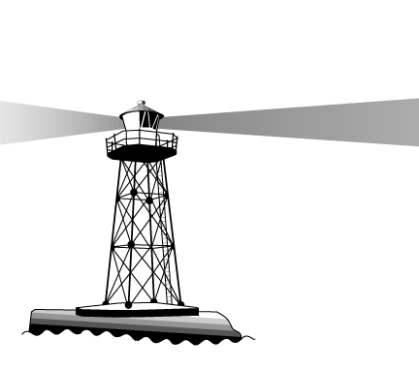
Larrakeyah Primary School

Pathways to Excellence

Mobile Phone and
Electronic Games
Policy

Mobile Phone and Electronic Games

Mobile phones are not allowed to be used at Larrakeyah School between 8:00am and 2:45 pm. Hand held electronic games are not to be used at any time in school grounds between 8:00am and 6:00 pm.

Guidelines:

Larrakeyah School believes that mobile phones and electronic games are not a suitable educational tool to be used during school hours. While mobile phones are a very useful device for students to be in contact with parents and other carers, they can be a serious distraction to the learning of the student. The school does not see any benefit in students having electronic games at school or at after school care. (There may be some special considerations made on camps, excursions and the last day of school.)

Students use:

- Mobile phones are not to be used in school grounds in school hours
- Mobile phones are to be switched off, handed to the teacher or handed in to the front office throughout the day
- Students may use their mobile phones once they have left the school grounds
- Students who are walking to Outside School Hours Care (OSHC) can ring their parents between 2:45pm and 3:00pm to discuss family arrangements
- Once students have arrived at after school care they are to switch their phones off and place them in their bags or hand them to after school care staff to look after them until their parents arrive

Non – Compliance

For students not adhering to the Mobile Phone and Electronic Games Policy the following procedure will take place:

- their equipment will be confiscated and held at the front office throughout the day
- Parents will be informed about the school’s Mobile Phone and Electronic Games Policy
- Phone call/interview with parent if child continues to use the above equipment
- The Principal may use his/her discretion after discussions with parents to determine the appropriate follow up action if a child continues to use the above equipment

Staff Use:
- Staff mobile phones should be turned off while they are teaching
- They can check and use their mobile phones at recess or lunch breaks or when they are on release time

